HESTA/ DAQ Protocol / LAL orsay – Jehanno – Rev. A – 29/03/05

START
START
ACTIVATED as CLIENT
HESTA
DAQ

ACTIVATED as SERVER
IP 134.158.90.89
PORT 1200

STEP 1
Asks for 123 UINT32
P
A
U
L
0
1
2
3
0x50,0x41,0x55,0x4C,
0x30,0x31,0x32,0x33
STEP 2

Sends 123 UINT32
STEP 3
STEP 4
Q
B
V
M
0
1
2
3
_
D
A
Y
_
_
2
9
M
O
N
T
_
_
_
3
Y
S
H
O
_
_
_
n

0x00

0x00

0x00

0x00

OK

4 NULL bytes

KO
Z
Z
Z
Z
0x5A,0x5A,0x5A,0x5A

STEP 1’
STEP 2’
P
A
U
L
0
1
2
3
STEP 3’
STEP 4’
Q
B
V
M
0
1
2
3
_
D
A
Y
_
_
2
9
M
O
N
T
_
_
_
3
Y
S
H
O
_
_
_
n

0x00

0x00

0x00

0x00
Asks for 123 UINT32

0x50,0x41,0x55,0x4C,
0x30,0x31,0x32,0x33

Sends 123 UINT32
OK

4 NULL bytes

KO
Z
Z
Z
Z
0x5A,0x5A,0x5A,0x5A

HESTA datas sent to DAQ / LAL orsay – Jehanno – Rev. A – 29/03/05

@ | 0 | 1 | 2 | 3 | 4 | 5 | 6 | 7 | EXAMPLE | NATURE | COMMENT
0 | Q | B | V | M | 0 | 1 | 2 | 3 | EXAMPLE | Magic String + Data Length | Header
8 | _ | D | A | Y | _ | _ | d | d | _DAY__29 | day | Date
16 | M | O | N | T | _ | _ | m | m | MONT___3 | month | Date
24 | Y | E | A | R | 2 | 0 | y | y | YEAR2005 | year | Date
32 | H | O | U | R | _ | _ | h | h | HOUR___8 | hour | Time
40 | M | I | N | U | _ | _ | m | m | MINU__10 | minute | Time
48 | S | E | C | O | _ | _ | s | s | SECO__33 | second | Time
56 | S | C | O | M | _ | _ | _ | y/n | SCOM___y | Status PC Com OK (RS232 I/O) | HESTA Status
64 | S | S | E | T | _ | _ | _ | y/n | SSET___y | Status Set OK | HESTA Status
72 | R | E | V | I | 2 | . | 1 | 8 | REVI____ | Soft. Revision | Indexer X datas
80 | M | O | C | U | 1 | 0 | 0 | % | MOCU____ | Motor Current | Indexer X datas
88 | M | O | S | T | _ | 7 | 0 | % | MOST____ | Motor Standby | Indexer X datas
96 | M | O | R | E | 4 | 0 | 0 | 0 | MORE____ | Motor Resolution | Indexer X datas
104 | V | E | L | O | 0 | . | 2 | 0 | VELO___? | Motor Velocity | Indexer X datas
112 | S | T | O | K | _ | _ | _ | y/n | STOK___y | Indexer Status OK | Indexer X datas
120 | M | O | V | E | _ | _ | _ | y/n | MOVE___n | Motor is Moving | Indexer X datas
128 | C | O | M | F | _ | _ | _ | y/n | COMF___n | Composite Fault | Indexer X datas
136 | C | U | R | F | _ | _ | _ | y/n | CURF___n | Current Fault | Indexer X datas
144 | S | U | P | F | _ | _ | _ | y/n | SUPF___n | Supply Fault | Indexer X datas
152 | A | M | B | F | _ | _ | _ | y/n | AMBF___n | Ambiant Temp. Fault | Indexer X datas
160 | D | R | V | F | _ | _ | _ | y/n | DRVF___n | Drive Fault | Indexer X datas
168 | C | F | G | F | _ | _ | _ | y/n | CFGF___n | Config Fault | Indexer X datas
176 | H | I | V | F | _ | _ | _ | y/n | HIVF___n | High Voltage Fault | Indexer X datas
184 | O | U | T | F | _ | _ | _ | y/n | OUTF___n | Out Fault | Indexer X datas
192 | L | I | M | P | _ | _ | _ | y/n | LIMP___n | Limit Plus | Indexer X datas
200 | L | I | M | M | _ | _ | _ | y/n | LIMM___n | Limit Minus | Indexer X datas
208 | P | O | S | S | s | s | s | s | POSS4000 | Stand X Position (1/100 mm) | Indexer X datas
216 | P | O | S | B | b | b | b | b | POSB___0 | Beam X position (1/100 mm) | Indexer X datas
224 | S | I | G | B | _ | _ | _ | p/m | SIGB___p | Beam X sign | Indexer X datas
232 | L | O | C | A | _ | _ | _ | y/n | LOCA___n | Local Mode On | X Side  Console datas
240 | R | I | G | H | _ | _ | _ | y/n | RIGH___n | Console X Right Button On | X Side  Console datas
248 | L | E | F | T | _ | _ | _ | y/n | LEFT___n | Console X Left Button On | X Side  Console datas
256 | X | H | O | M | _ | _ | _ | y/n | XHOM___n | Console X Home Button On | X Side  Console datas
264 | X | S | H | O | _ | _ | _ | y/n | XSHO___n | Console X Set Home Button On | X Side  Console datas
272 | L | A | M | P | _ | _ | _ | y/n | LAMP___n | User Lamp On | X Side  Console datas
280 | R | E | V | I | 2 | . | 1 | 8 | REVI___X | Soft. Revision | Indexer Y datas
288 | M | O | C | U | 1 | 0 | 0 | % | MOCU___X | Motor Current | Indexer Y datas
296 | M | O | S | T | _ | 7 | 0 | % | MOST___X | Motor Standby | Indexer Y datas
304 | M | O | R | E | 4 | 0 | 0 | 0 | MORE___X | Motor Resolution | Indexer Y datas
312 | V | E | L | O | 4 | . | 0 | 0 | VELO___X | Motor Velocity | Indexer Y datas
320 | S | T | O | K | _ | _ | _ | y/n | STOK___y | Indexer Status OK | Indexer Y datas
328 | M | O | V | E | _ | _ | _ | y/n | MOVE___n | Motor is Moving | Indexer Y datas
336 | C | O | M | F | _ | _ | _ | y/n | COMF___n | Composite Fault | Indexer Y datas
344 | C | U | R | F | _ | _ | _ | y/n | CURF___n | Current Fault | Indexer Y datas
352 | S | U | P | F | _ | _ | _ | y/n | SUPF___n | Supply Fault | Indexer Y datas
360 | A | M | B | F | _ | _ | _ | y/n | AMBF___n | Ambiant Temp. Fault | Indexer Y datas
372 | D | R | V | F | _ | _ | _ | y/n | DRVF___n | Drive Fault | Indexer Y datas
380 | C | F | G | F | _ | _ | _ | y/n | CFGF___n | Config Fault | Indexer Y datas
388 | H | I | V | F | _ | _ | _ | y/n | HIVF___n | High Voltage Fault | Indexer Y datas
396 | O | U | T | F | _ | _ | _ | y/n | OUTF___n | Out Fault | Indexer Y datas
404 | L | I | M | P | _ | _ | _ | y/n | LIMP___n | Limit Plus | Indexer Y datas
412 | L | I | M | M | _ | _ | _ | y/n | LIMM___n | Limit Minus | Indexer Y datas
420 | P | O | S | S | s | s | s | s | POSS2500 | Stand Y Position (1/100 mm) | Indexer Y datas
428 | P | O | S | B | b | b | b | b | POSB_500 | Beam Y position (1/100 mm) | Indexer Y datas
436 | S | I | G | B | _ | _ | _ | p/m | SIGB___n | Beam Y sign | Indexer Y datas
444 | S | U | N | C | _ | _ | _ | y/n | SUNC___n | Brake Uncoupled Switch On | Y Side  Console datas
452 | B | U | N | C | _ | _ | _ | y/n | BUNC___n | Brake Uncoupled On | Y Side  Console datas
460 | _ | _ | U | P | _ | _ | _ | y/n | __UP___n | Console Y Up Button On | Y Side  Console datas
468 | D | O | W | N | _ | _ | _ | y/n | DOWN___n | Console Y Down Button On | Y Side  Console datas
476 | Y | H | O | M | _ | _ | _ | y/n | YHOM___n | Console Y Home Button On | Y Side  Console datas
484 | Y | S | H | O | _ | _ | _ | y/n | YSHO___n | Console Y Set Home Button On | Y Side  Console datas
492 | \0 | \0 | \0 | \0 |  |  |  |  |  | 4 bytes = 0x00 (Null char.) | End of Datas

DATAS structure sent to DAQ / LAL orsay – Jehanno – Rev. A – 29/03/05

// Union des données INDEXER pour DAQ
typedef union
{
char Chaine[DAQ_DATA_LENGTH*4]; // DAQ_DATA_LENGTH = 123 (UINT32)
// The Chaine field is a 123x4 char array. This
// array is sent each time the DAQ asks for datas
StDAQ Daq; // The StDAQ structure is updated each time
// the DAQ asks for datas
}UnionDAQ;

// Structure des données DAQ
typedef struct
{
// Entete
char MagicNumber[4]; // QBVM
// Longueur de la chaine
char LengthDaq[4]; // 123 UINT32
// Date
char DayText[4]; // _DAY
char DayVal[4]; // __dd
char MonthText[4]; // MONT
char MonthVal[4]; // __mm
char YearText[4]; // YEAR
char YearVal[4]; // __yy
// Heure
char HourText[4]; // HOUR
char HourVal[4]; // __hh
char MinuteText[4]; // MINU
char MinuteVal[4]; // __mm
char SecondText[4]; // SECO
char SecondVal[4]; // __ss
// Status
char StatusComText[4]; // SCOM
char StatusComVal[4]; // ___y ou ___n
char StatusSetText[4]; // SSET
char StatusSetVal[4]; // ___y ou ___n

// INDEXER X
StIndexerDaq IndexerX; // SEE BELOW

// CONSOLE
char ModeLocalText[4]; // LOCA
char ModeLocalVal[4]; // ___y ou ___n
char RightText[4]; // RIGH
char RightVal[4]; // ___y ou ___n
char LeftText[4]; // LEFT
char LeftVal[4]; // ___y ou ___n
char XHomeText[4]; // XHOM
char XHomeVal[4]; // ___y ou ___n
char XSetHomeText[4]; // XSHO
char XSetHomeVal[4]; // ___y ou ___n
char UserLampText[4]; // LAMP
char UserLampVal[4]; // ___y ou ___n

// INDEXER Y
StIndexerDaq IndexerY; // SEE BELOW

// CONSOLE
char BrakeUncoupledSwitchText[4]; // SUNC
char BrakeUncoupledSwitchVal[4]; // ___y ou ___n
char BrakeUncoupledText[4]; // BUNC
char BrakeUncoupledVal[4]; // ___y ou ___n
char UpText[4]; // __UP
char UpVal[4]; // ___y ou ___n
char DownText[4]; // DOWN
char DownVal[4]; // ___y ou ___n
char YHomeText[4]; // YHOM
char YHomeVal[4]; // ___y ou ___n
char YSetHomeText[4]; // YSHO
char YSetHomeVal[4]; // ___y ou ___n
char EndString[4]; // 0x00000000
}StDAQ;
// Structure des données INDEXER pour DAQ
typedef struct
{
// General
char RevisionText[4]; // REVI
char RevisionVal[4]; // 2.18
char MotorCurrentText[4]; // MOCU
char MotorCurrentVal[4]; // 100%
char MotorStandbyText[4]; // MOST
char MotorStandbyVal[4]; // _70%
char MotorResolutionText[4]; // MORE
char MotorResolutionVal[4]; // 4000
char MotorVelocityText[4]; // VELO
char MotorVelocityVal[4]; // 0.20 ou 4.00
// Status
char StatusOKText[4]; // STOK
char StatusOKVal[4]; // ___y ou ___n
// Moving
char MovingText[4]; // MOVE
char MovingVal[4]; // ___y ou ___n
// Defauts
char CompositeFaultText[4]; // COMF
char CompositeFaultVal[4]; // ___y ou ___n
char CurrentFaultText[4]; // CURF
char CurrentFaultVal[4]; // ___y ou ___n
char SupplyFaultText[4]; // SUPF
char SupplyFaultVal[4]; // ___y ou ___n
char AmbiantFaultText[4]; // AMBF
char AmbiantFaultVal[4]; // ___y ou ___n
char DriveFaultText[4]; // DRVF
char DriveFaultVal[4]; // ___y ou ___n
char ConfigFaultText[4]; // CFGF
char ConfigFaultVal[4]; // ___y ou ___n
char HighVoltFaultText[4]; // HIVF
char HighVoltFaultVal[4]; // ___y ou ___n
char OutFaultText[4]; // OUTF
char OutFaultVal[4]; // ___y ou ___n
// Limites
char LimitPlusText[4]; // LIMP
char LimitPlusVal[4]; // ___y ou ___n
char LimitMoinsText[4]; // LIMM
char LimitMoinsVal[4]; // ___y ou ___n
// Position
char PosStandText[4]; // POSS
char PosStandVal[4]; // xxxx
char PosBeamText[4]; // POSB
char PosBeamVal[4]; // xxxx
char SignBeamText[4]; // SIGB
char SignBeamVal[4]; // xxxx
}StIndexerDaq;

STAND / BEAM POSITIONS sent to DAQ / LAL orsay – Jehanno – Rev. A – 29/03/05

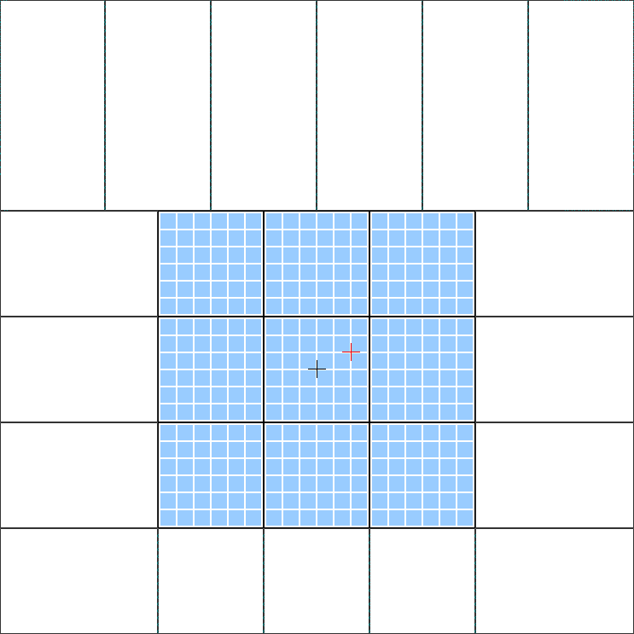
62mm=124pix
62mm=124pix
62mm=124pix
62mm=124pix
62mm=124pix
62mm=124pix
62mm=124pix
372mm=744 pix
372mm=
744 pix
93mm=186pix
62mm=124pix
93mm=186pix
124mm=
248pix
0
+40 000
-40 000
-80 000
-120 000
+120 000
+80 000
PA(X)
PA(Y)

NOTA

The X Stand position is centered at 4000.
The Y Stand position is centered at 1950.
The X and Y Beam positions are expressed relatively to the X and Y positions (can be positive or negative).

