IDAQ v1 Manual

Version 0.1
31/07/2026

John Jones (john.jones@imperial.ac.uk)

HEP Silicon Group, Imperial College London

1.0 Overview 3
2.0 Component Description 4
2.1 FPGA (XC2VP20-6FF1152C) 4
2.2 Compact Flash 4
2.3 DDR Memory 4
2.4 10/100 Mb/s Ethernet 4
2.5 USB 4
2.6 VME Interface 5
2.7 Power Regulators 5
2.8 General-Purpose I/O 5
3.0 Layout 7
4.0 Upgrade Possibilities 9
5.0 Board Specifications 10

1.0 Introduction

Summary taken from the IDAQ v1 Overview:

“The Imperial DAQ (IDAQ) card is a 12-layer 6U VME card, and as such has dimensions 233.5 x 160 mm. Although designed to sit in a crate it can also operate on a workbench using an external 5V power jack.

The main features of the board are:

- A 2 Million Gate FPGA
- 3 Switch-mode main power regulators supplying up to 15A each
- 2 PPC 405 processor cores each capable of ~500 DMIPS @ 350 MHz
- 8 Rocket IO transceivers each operating at up to 3 GHz
- 128 MB DDR SDRAM operating at 60-200 MHz (800-1600 MB/s)
- ~270 flexible I/O Connections
- Board & FPGA temperature monitoring
- VME Interface (D16 Slave only)
- USB 2.0 Interface
- 10/100 Mb/s Ethernet Interface
- Compact Flash-based System Initialisation

The majority of the board operates at +2.5V (including almost all of the I/O lines), with some on-board components operating at +3.3V. The FPGA core itself operates off an independent +1.5V supply. Additional power regulators are included on the board for other features of the FPGA and the memory subsystem, as discussed later.

The FPGA chosen for the new board is the Virtex-II Pro, manufactured by Xilinx. It is approximately a 2 million gate device, and also has several other unique features. The XC2VP20 contains two embedded microprocessor cores (based on the IBM PPC 405) which are immersed inside the FPGA fabric. This allows one to combine the benefits of parallel processing in FPGAs with the raw computational power of a fast processor (in fact this device can run a variant of the Linux operating system). Another unusual feature of the FPGA is the SERDES (SERializer-DESerializer) transceivers (also known as Rocket IO). They can be used to provide a direct high-bandwidth link to the FPGA; for example it is fairly trivial to connect the device directly to a hard drive via an SATA link, or implement a Gigabit Ethernet connection if required. However although they are routed to the connectors on the board their stability was never simulated and cannot (yet) be guaranteed.”

This document goes into further detail about the principles of operation of the IDAQ v1 from a hardware perspective. Firmware modules are described in the IDAQ v1 Firmware Guide.

2.0 On-Board Modules

2.1 FPGA (XC2VP20-6FF1152C)

The XC2VP20 device is a two million gate FPGA, however this does not clearly define the performance of the device as it is dependent on the architecture of the FPGA. It supports Digitally Controlled Impedance (DCI) which helps to maintain signal integrity and also includes internal differential terminations for LVDS, so external resistors aren’t needed except for long-trace single-ended inputs when DCI is not being used.

2.2 Compact Flash

FPGAs are soft-programmable devices, and as such 'forget' their configuration on power-down. We therefore require a non-volatile storage area that can reprogram the device on power-up. In the past this was achieved using a boot PROM; however, in order to take advantages of new features in the FPGA and provide additional non-volatile storage space, the IDAQ is initialised via a JTAG boundary scan, using a bitstream stored in a Compact Flash (CF) card. This allows one to change between board applications by changing a switch on the board. The CF card is also used to store the software running on the PPC cores if they are being used. Eight firmware variants can be stored on the card at any one time.

2.3 DDR Memory

The memory interface is designed to operate at close to a maximum speed of 400 Mb/s/pin Double Data Rate (200 MHz clock) on a 32-bit wide bus. This is achieved using four 8-bit components in parallel combined with a clock splitter and a bus power supply. This is probably the most sensitive part of the board, both in terms of firmware and hardware design. The data capture window for read and write cycles has to be synchronised to within a few nanoseconds of a clock edge, so to maintain signal integrity avoid errors requires precise routing and controlled impedance traces between the memory and the FPGA.

The firmware for the memory is designed to operate in one of two modes, both of which have been crudely synthesised from VHDL using Precision Synthesis and simulated using ModelSim. The termination has also been simulated using Spice.

2.4 10/100 Mb/s Ethernet

Most of the details of the Ethernet link are handled by the FPGA itself. The Intel LXT972A handles conversion of signals from the FPGA to those used in a standard CAT5 network. It should be noted that the Ethernet Media Access Controller (MAC) implementation is quite resource-hungry, using approximately 10% of the FPGA when synthesised.

2.5 USB

The USB device is a Cypress SX2 USB controller, (CY7C68001) which handles the complexities of the USB protocol and provides a ‘dumb’ microcontroller / FIFO (First In First Out) interface. It supports bus speeds of up to 480 Mb/s when operating in its fastest (synchronous) mode. It was decided that having a full microcontroller such as the Cypress FX2 wasn’t necessary, as any on-board processing can be handled by the FPGA, and debugging multiprocessor systems is more complicated. In real terms the peak transfer rate has been found to be ~40 MB/s in a similar system, or approximately 2/3 of the theoretical maximum.

2.6 VME Interface

The VME interface only allows operation as a standard D16 slave, but considering the other technologies available for high-speed data throughput, it was decided that the design of a VME 64X interface wasn’t a priority. Furthermore D8(O) and D8(E) modes are note supported; neither are block transfers, although this could be implemented in firmware.

2.7 Power Regulators

The input supply ratings are defined in the table below. The power line is first filtered capacitatively with a 20A-rated ferrite bead from Syfer (SBSMC0500474MX). This feeds into three switched-mode power regulators that support the different features of the board:

- PTH05010 Switching Regulators – Manufactured by Texas Instruments, these regulators offer a plug-in solution for powering a Virtex-II Pro device. There are three regulators, supplying +3.3V, +2.5V and +1.5V to the board. The auto-track feature is used to synchronise the supply to each power line, although it isn’t strictly required by the FPGA specifications. They are rated to supply 15 Amps per supply line, which should be considerably greater than that required for the board itself. Hence they should be sufficient to also supply any daughter cards.

The supplies from these regulators feed directly into some components on the board, and are further filtered by:

- LT1963 Linear Regulators – These are used to supply the eight Rocket I/O Multi-Gigabit Transceivers (MGTs) on the FPGA, which require a very low-ripple power supply for correct operation.
- ML6554CU Bus-Termination Regulator – This regulator supplies the termination resistors and reference voltage (+1.25V) required for DDR memory (as per the SSTL I/II JEDEC specifications).

2.8 General-Purpose I/O

The general-purpose I/O on the IDAQ can be adapted to any function depending on the requirements of a given project. The only limitation is that the supply voltage for the banks is fixed almost exclusively at +2.5V. The reason for this is that even a small (~4.05V) overshoot in a signal operating at this voltage can damage the FPGA (the clamp diodes won’t activate in time and the gate oxide will be damaged). However this doesn’t preclude the possibility of using line-level shifters or multiplexers. The following I/O standards are supported on the available I/O:

Number of I/O | I/O Standard | Voltages | Comments
188+10 | LVCMOS | +2.5V supply | Standard CMOS driver
188+10 | LVDCI | +2.5V supply | Controlled Impedance
188+10 | LVPECL | +2.5V supply | Standard ECL driver
188+10 | LDT | +2.5V supply | Hypertransport
188+10 | LVDS | +2.5V supply | Differential – divide I/O count by 2 (except items marked in red).
2 | LVCMOS | +3.3V supply | Standard CMOS driver
2 | LVDCI | +3.3V supply | Controlled Impedance
62+8 | LVCMOS, LVDCI, LVPECL, LDT, LVDS | +2.5V supply | As above
62+8 | SSTL_I, SSTL_II | +2.5V supply  +1.25V V_{ref} | Stub-series termination. Requires specialised V_{ref}
4 (pairs) | LVDS | +2.5V | LVDS input only

Other I/O can be made available with minor modifications to the board, but this is not recommended. In total there are 270 single-ended I/O available without modification. The I/O highlighted in red is restricted to single-ended operation only.

3.0 Layout
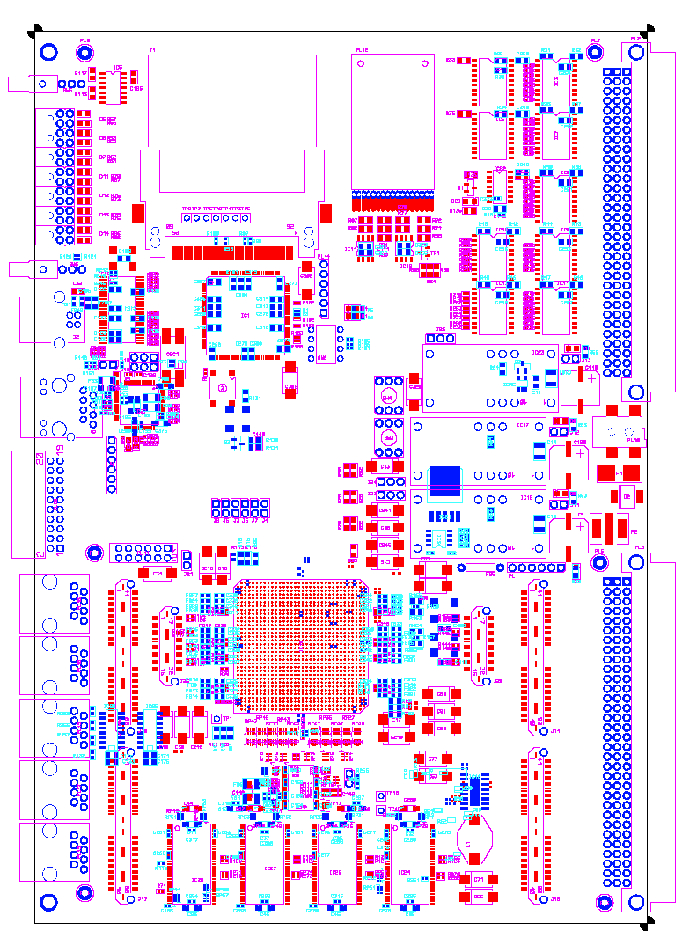
2

4

5

20

21

15

16

2

18

19

13

11

14

12

8

6

1

7

9

10

3

17

17

14

14

14

14

22

Item Number | Feature Description
1 | Soft-reset switch
2 | Compact flash card holder & System ACE programming IC
3 | JTAG programming header and firmware select switch
4 | APV25 ASIC
5 | VMEbus interface ICs
6 | Front-panel LEDs
7 | Configurable board switch
8 | USB 2.0 port and Cypress SX2 IC
9 | Ethernet port and LXT972A IC
10 | Power supply regulators
11 | Pipe address connector (in 10x2 IDC header format) (20 I/O)
12 | General I/O header (6x2) from FPGA bank 7 (12 I/O)  Standard pins, 1 mm pitch
13 | JTAG chain header (bridge to support multiple-FPGA programming)
14 | Front-panel I/O (32 single-ended I/O, 4 LVDS input pairs)
15 | General I/O Header for FPGA banks 0, 1 (62+6 I/O)  Samtec QTH-040-F-D-DP-A connector
16 | General I/O Header for FPGA banks 1, 2 (40+5 I/O)  Samtec QTH-040-F-D-DP-A connector
17 | Rocket I/O connectors (4 RX/TX groups each)  Samtec QFSS-DP connector
18 | Main FPGA (XC2VP20)
19 | DDR Memory
20 | General I/O Header for FPGA banks 4, 5 (34 I/O)  Samtec QTH-040-F-D-DP-A connector  N.B. Two I/O on this bank operate at +3.3V
21 | General I/O Header for FPGA banks 3, 4 (54+7 I/O)  Samtec QTH-040-F-D-DP-A connector
22 | Daughter-card power header (+5V, +3.3V, +2.5V, +1.5V, GND)

4.0 Upgrade Possibilities

The IDAQ was designed with upgradeability in mind, and as such there are a number of ways that the parts used can be changed without any modification of the PCB, saving prototyping costs.

- The FPGA part XC2VP20 is pin compatible with a version of the XC2VP30, 40 and 50, allowing for a 250% increase in available logic.
- The 5V power regulators are designed by Texas Instruments (PTH05010). They can be replaced with pin-compatible 12V converters to supply more power when the card is being used outside of a VME crate (provided VME bus transceivers are depopulated).
- The DDR memory chips can be replaced to offer a total on-board memory of 512 MB. This requires the four 256 Mb ICs to be replaced with their 1 Gb counterparts.
5 Generic Firmware

The generic cores are those which are required to access all the features of the IDAQ. There are several of these, all in various stages of development:

Firmware Module | Status | Comments
VME | Firmware complete | Awaiting testing on prototype
Ethernet | Firmware nearly complete | Awaiting testing on prototype
Memory | Under development | Awaiting testing on prototype
System ACE | TBD | TBD
USB | Under development | Awaiting testing on prototype
Thermal Management | Under development | Awaiting testing on prototype
Rocket I/O | N/A (Application-Specific) | Awaiting testing on prototype
6 Board Specifications

This section is a summary of the specifications of the IDAQ and the possible alternative configurations. Sections highlighted in red require either component changes or minor PCB alterations.

Board System | Effect on Board Specification
Main Power (Texas)  Configuration 1  VME Operation  Using PTH05010  Configuration 2  Desk Operation  Using PTH05010  Configuration 3  Desk Operation  Using PTH12010 | Input Supply Rating: 5V @ 15A/10A (20˚C/70˚C)  Peak board power dissipation: 75W / 50W (20˚C/70˚C)  Input Supply Rating: 5V @ 5A  Peak board power dissipation: 25W  Input Supply Rating 12V @ 5A  Peak board power dissipation: 60W
Rocket I/O  Power (Linear Technology)  LT1963EQ-2.5  LT1963ES8  Connectors (Samtec)  QMSS-016-11-H-D-DP-A * 2 | +2.5V, 1.5A VCCAUX  +1.8V, 1.5A VTT  4 RIO sets per connector (8 total) ~ 3 GHz max. speed
Ethernet  Interface IC (Intel)  Intel LXT972A  Ethernet Connector (Belfuse)  SI-40245 | +3.3V core, +2.5V I/O PHY  Integrated magnetics
USB 2.0  Interface IC (Cypress)  CY7C68001 (SX2)  USB Connector (Molex)  B-type | +3.3V supply  FIFO-like command/data interface  Full (12 Mb/s) / High (480 Mb/s) speed device
DDR  Bus Power (Fairchild Semi.)  ML6554CU  Clock Splitter (Texas)  CDCV857  Memory IC (Micron)  128 MB  256 MB  512 MB  1024 MB | Supplies termination resistors for DDR memory bus  Operating speed 60-200 MHz  (FPGA firmware-dependent)  4x Micron 256Mb (8-bit data)  4x Micron 512Mb (8-bit data)  4x Micron 1Gb (8-bit data)  8x Micron 1Gb (8-bit data)  NB 1GB requires PCB alteration
VME  D16 Slave | +3.3V supply  Supports D16 operation ONLY (~5MB/s)
FPGA (Xilinx)  XC2VP20  XC2VP30  XC2VP40  XC2VP50 | ~2 Million Gate, 20,880 Logic Cells, 2 PPC 405s  ~3 Million Gate, 30,816 Logic Cells, 2 PPC 405s  ~4 Million Gate, 46,632 Logic Cells, 2 PPC 405s  ~5 Million Gate, 53,136 Logic Cells, 2 PPC 405s

Application-dependent as all supplies derive from the same 5V, 5A supply (although the regulator could be upgraded to 12V)

